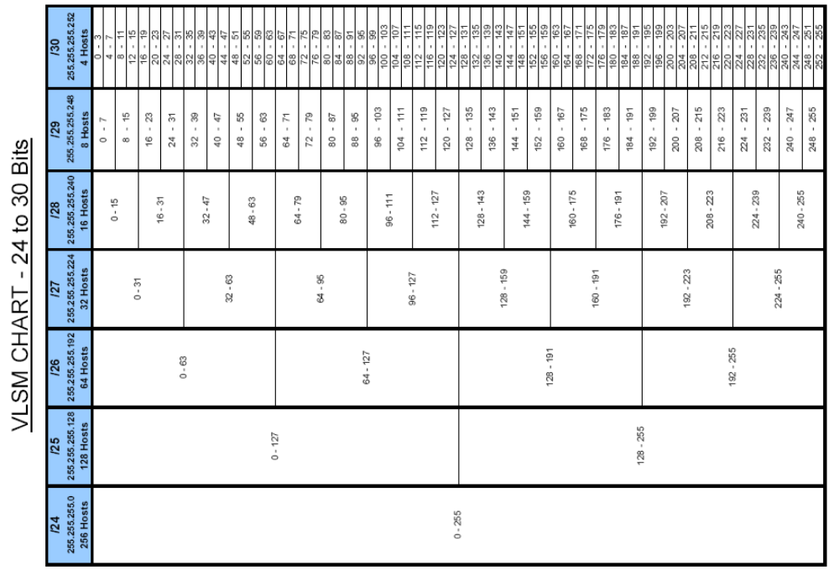
Solution - VLSM Exercise # 1

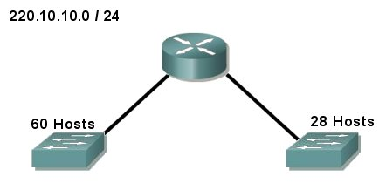
220.10.10.0 / 26
220.10.10.64 / 27
Solution - VLSM Exercise # 1

220.10.10.0 / 24
 | Network: | 1 | 1 | 0 | 1 | 1 | 1 | 0 | 0 | . | 0 | 0 | 0 | 0 | 1 | 0 | 1 | 0 | . | 0 | 0 | 0 | 0 | 1 | 0 | 1 | 0 | . | 0 | 0 | 0 | 0 | 0 | 0 | 0 | 0
 | Subnet Mask: | 1 | 1 | 1 | 1 | 1 | 1 | 1 | 1 | . | 1 | 1 | 1 | 1 | 1 | 1 | 1 | 1 | . | 1 | 1 | 1 | 1 | 1 | 1 | 1 | 1 | . | 0 | 0 | 0 | 0 | 0 | 0 | 0 | 0
 |  | Borrow 2 - 26 Network bits - 6 Host bits - Magic Number = 64
60 Hosts | 220.10.10.0 / 26 | 1 | 1 | 0 | 1 | 1 | 1 | 0 | 0 | . | 0 | 0 | 0 | 0 | 1 | 0 | 1 | 0 | . | 0 | 0 | 0 | 0 | 1 | 0 | 1 | 0 | . | 0 | 0 | 0 | 0 | 0 | 0 | 0 | 0
 | 220.10.10.64 / 26 |  |  |  |  |  |  |  |  |  |  |  |  |  | • |  |  |  |  |  |  |  |  |  |  |  |  |  | 0 | 1
 | 220.10.10.128 / 26 |  |  |  |  |  |  |  |  |  |  |  |  |  | • |  |  |  |  |  |  |  |  |  |  |  |  |  | 1 | 0
 | 220.10.10.192 / 26 | 1 | 1 | 0 | 1 | 1 | 1 | 0 | 0 | . | 0 | 0 | 0 | 0 | 1 | 0 | 1 | 0 | . | 0 | 0 | 0 | 0 | 1 | 0 | 1 | 0 | . | 1 | 1 | 0 | 0 | 0 | 0 | 0 | 0
 | Subnet Mask: | 1 | 1 | 1 | 1 | 1 | 1 | 1 | 1 | . | 1 | 1 | 1 | 1 | 1 | 1 | 1 | 1 | . | 1 | 1 | 1 | 1 | 1 | 1 | 1 | 1 | . | 1 | 1 | 0 | 0 | 0 | 0 | 0 | 0
 |  | Borrow 1 More - 27 Network bits - 5 Host bits - Magic Number = 32
28 Hosts | 220.10.10.64 / 27 | 1 | 1 | 0 | 1 | 1 | 1 | 0 | 0 | . | 0 | 0 | 0 | 0 | 1 | 0 | 1 | 0 | . | 0 | 0 | 0 | 0 | 1 | 0 | 1 | 0 | . | 0 | 1 | 0 | 0 | 0 | 0 | 0 | 0
 | 220.10.10.96 / 27 |  |  |  |  |  |  |  |  |  |  |  |  |  |  |  |  |  |  |  |  |  |  |  |  |  |  |  |  |  | 1
 | Subnet Mask: | 1 | 1 | 1 | 1 | 1 | 1 | 1 | 1 | . | 1 | 1 | 1 | 1 | 1 | 1 | 1 | 1 | . | 1 | 1 | 1 | 1 | 1 | 1 | 1 | 1 | . | 1 | 1 | 1 | 0 | 0 | 0 | 0 | 0

Solution - VLSM Exercise # 2

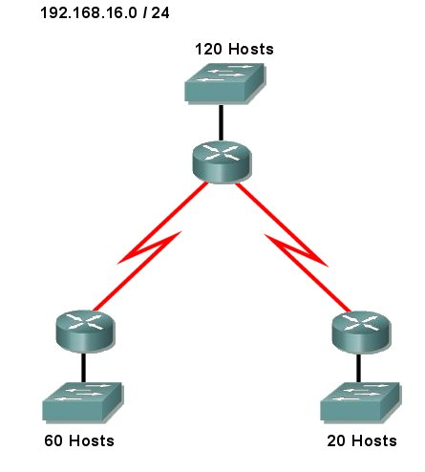
192.168.16.0 / 25
192.168.16.228 / 30
192.168.16.224 / 30
192.168.16.192 / 27
192.168.16.128 / 26
Solution - VLSM Exercise # 2

192.168.16.0 / 24
 | Network: | 1 | 1 | 0 | 0 | 0 | 0 | 0 | 0 | . | 1 | 0 | 1 | 0 | 1 | 0 | 0 | 0 | . | 0 | 0 | 0 | 1 | 0 | 0 | 0 | 0 | . | 0 | 0 | 0 | 0 | 0 | 0 | 0 | 0
 | Subnet Mask: | 1 | 1 | 1 | 1 | 1 | 1 | 1 | 1 | . | 1 | 1 | 1 | 1 | 1 | 1 | 1 | 1 | . | 1 | 1 | 1 | 1 | 1 | 1 | 1 | 1 | . | 0 | 0 | 0 | 0 | 0 | 0 | 0 | 0
 |  | Borrow 1 - 25 Network bits - 7 Host bits - Magic Number = 128
120 Hosts | 192.168.16.0 / 25 | 1 | 1 | 0 | 0 | 0 | 0 | 0 | 0 | . | 1 | 0 | 1 | 0 | 1 | 0 | 0 | 0 | . | 0 | 0 | 0 | 1 | 0 | 0 | 0 | 0 | . | 0 | 0 | 0 | 0 | 0 | 0 | 0 | 0
 | 192.168.16.128 / 25 |  |  |  |  |  |  |  |  |  |  |  |  |  |  |  |  |  |  |  |  |  |  |  |  |  |  |  | 1
 | Subnet Mask: | 1 | 1 | 1 | 1 | 1 | 1 | 1 | 1 | . | 1 | 1 | 1 | 1 | 1 | 1 | 1 | 1 | . | 1 | 1 | 1 | 1 | 1 | 1 | 1 | 1 | . | 1 | 0 | 0 | 0 | 0 | 0 | 0 | 0
 |  | Borrow 1 More - 26 Network bits - 6 Host bits - Magic Number = 64
60 Hosts | 192.168.16.128 / 26 | 1 | 1 | 0 | 0 | 0 | 0 | 0 | 0 | . | 1 | 0 | 1 | 0 | 1 | 0 | 0 | 0 | . | 0 | 0 | 0 | 1 | 0 | 0 | 0 | 0 | . | 1 | 0 | 0 | 0 | 0 | 0 | 0 | 0
 | 192.168.16.192 / 26 |  |  |  |  |  |  |  |  |  |  |  |  |  |  |  |  |  |  |  |  |  |  |  |  |  |  |  |  | 1
 | Subnet Mask: | 1 | 1 | 1 | 1 | 1 | 1 | 1 | 1 | . | 1 | 1 | 1 | 1 | 1 | 1 | 1 | 1 | . | 1 | 1 | 1 | 1 | 1 | 1 | 1 | 1 | . | 1 | 1 | 0 | 0 | 0 | 0 | 0 | 0
 |  | Borrow 1 More - 27 Network bits - 5 Host bits - Magic Number = 32
20 Hosts | 192.168.16.192 / 27 | 1 | 1 | 0 | 0 | 0 | 0 | 0 | 0 | . | 1 | 0 | 1 | 0 | 1 | 0 | 0 | 0 | . | 0 | 0 | 0 | 1 | 0 | 0 | 0 | 0 | . | 1 | 1 | 0 | 0 | 0 | 0 | 0 | 0
 | 192.168.16.224 / 27 |  |  |  |  |  |  |  |  |  |  |  |  |  |  |  |  |  |  |  |  |  |  |  |  |  |  |  |  |  | 1
 | Subnet Mask: | 1 | 1 | 1 | 1 | 1 | 1 | 1 | 1 | . | 1 | 1 | 1 | 1 | 1 | 1 | 1 | 1 | . | 1 | 1 | 1 | 1 | 1 | 1 | 1 | 1 | . | 1 | 1 | 1 | 0 | 0 | 0 | 0 | 0
 |  | Borrow 3 More - 30 Network bits - 2 Host bits - Magic Number = 4
2 Hosts | 192.168.16.224 / 30 | 1 | 1 | 0 | 0 | 0 | 0 | 0 | 0 | . | 1 | 0 | 1 | 0 | 1 | 0 | 0 | 0 | . | 0 | 0 | 0 | 1 | 0 | 0 | 0 | 0 | . | 1 | 1 | 1 | 0 | 0 | 0 | 0 | 0
2 Hosts | 192.168.16.228 / 30 |  |  |  |  |  |  |  |  |  |  |  |  |  | • |  |  |  |  |  |  |  |  |  |  |  |  |  |  |  |  | 0 | 0 | 1
 | • |  |  |  |  |  |  |  |  |  |  |  |  |  | • |  |  |  |  |  |  |  |  |  |  |  |  |  |  |  |  |  | •
 | • |  |  |  |  |  |  |  |  |  |  |  |  |  | • |  |  |  |  |  |  |  |  |  |  |  |  |  |  |  |  |  | •
 | • |  |  |  |  |  |  |  |  |  |  |  |  |  | • |  |  |  |  |  |  |  |  |  |  |  |  |  |  |  |  |  | •
 | 192.168.16.252 / 30 | 1 | 1 | 0 | 0 | 0 | 0 | 0 | 0 | . | 1 | 0 | 1 | 0 | 1 | 0 | 0 | 0 | . | 0 | 0 | 0 | 1 | 0 | 0 | 0 | 0 | . | 1 | 1 | 1 | 1 | 1 | 1 | 0 | 0
 | Subnet Mask: | 1 | 1 | 1 | 1 | 1 | 1 | 1 | 1 | . | 1 | 1 | 1 | 1 | 1 | 1 | 1 | 1 | . | 1 | 1 | 1 | 1 | 1 | 1 | 1 | 1 | . | 1 | 1 | 1 | 1 | 1 | 1 | 0 | 0

Solution - VLSM Exercise # 3

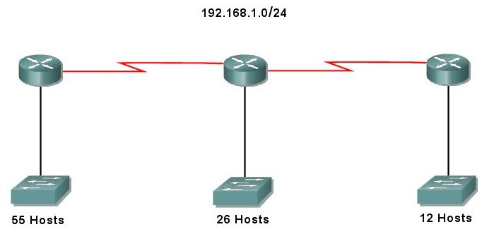
192.168.1.0 / 26
192.168.1.64 / 27
192.168.1.96 / 28
192.168.1.112 / 30
192.168.1.116 / 30

Solution - VLSM Exercise # 3

192.168.1.0 / 24
 | Network: | 1 | 1 | 0 | 0 | 0 | 0 | 0 | 0 | . | 1 | 0 | 1 | 0 | 1 | 0 | 0 | 0 | . | 0 | 0 | 0 | 0 | 0 | 0 | 0 | 1 | . | 0 | 0 | 0 | 0 | 0 | 0 | 0 | 0
 | Subnet Mask: | 1 | 1 | 1 | 1 | 1 | 1 | 1 | 1 | . | 1 | 1 | 1 | 1 | 1 | 1 | 1 | 1 | . | 1 | 1 | 1 | 1 | 1 | 1 | 1 | 1 | . | 0 | 0 | 0 | 0 | 0 | 0 | 0 | 0
 |  | Borrow 2 - 26 Network bits - 6 Host bits - Magic Number = 64
55 Hosts | 192.168.1.0 / 26 | 1 | 1 | 0 | 0 | 0 | 0 | 0 | 0 | . | 1 | 0 | 1 | 0 | 1 | 0 | 0 | 0 | . | 0 | 0 | 0 | 0 | 0 | 0 | 0 | 1 | . | 0 | 0 | 0 | 0 | 0 | 0 | 0 | 0
 | 192.168.1.64 / 26 |  |  |  |  |  |  |  |  |  |  |  |  |  | • |  |  |  |  |  |  |  |  |  |  |  |  |  | 0 | 1
 | 192.168.1.128 / 26 |  |  |  |  |  |  |  |  |  |  |  |  |  | • |  |  |  |  |  |  |  |  |  |  |  |  |  | 1 | 0
 | 192.168.1.192 / 26 | 1 | 1 | 0 | 0 | 0 | 0 | 0 | 0 | . | 1 | 0 | 1 | 0 | 1 | 0 | 0 | 0 | . | 0 | 0 | 0 | 0 | 0 | 0 | 0 | 1 | . | 1 | 1 | 0 | 0 | 0 | 0 | 0 | 0
 | Subnet Mask: | 1 | 1 | 1 | 1 | 1 | 1 | 1 | 1 | . | 1 | 1 | 1 | 1 | 1 | 1 | 1 | 1 | . | 1 | 1 | 1 | 1 | 1 | 1 | 1 | 1 | . | 1 | 1 | 0 | 0 | 0 | 0 | 0 | 0
 |  | Borrow 1 More - 27 Network bits - 5 Host bits - Magic Number = 32
26 Hosts | 192.168.1.64 / 27 | 1 | 1 | 0 | 0 | 0 | 0 | 0 | 0 | . | 1 | 0 | 1 | 0 | 1 | 0 | 0 | 0 | . | 0 | 0 | 0 | 0 | 0 | 0 | 0 | 1 | . | 0 | 1 | 0 | 0 | 0 | 0 | 0 | 0
 | 192.168.1.96 / 27 |  |  |  |  |  |  |  |  |  |  |  |  |  |  |  |  |  |  |  |  |  |  |  |  |  |  |  |  |  | 1
 | Subnet Mask: | 1 | 1 | 1 | 1 | 1 | 1 | 1 | 1 | . | 1 | 1 | 1 | 1 | 1 | 1 | 1 | 1 | . | 1 | 1 | 1 | 1 | 1 | 1 | 1 | 1 | . | 1 | 1 | 1 | 0 | 0 | 0 | 0 | 0
 |  | Borrow 1 More - 28 Network bits - 4 Host bits - Magic Number = 16
12 Hosts | 192.168.1.96 / 28 | 1 | 1 | 0 | 0 | 0 | 0 | 0 | 0 | . | 1 | 0 | 1 | 0 | 1 | 0 | 0 | 0 | . | 0 | 0 | 0 | 0 | 0 | 0 | 0 | 1 | . | 0 | 1 | 1 | 0 | 0 | 0 | 0 | 0
 | 192.168.1.112 /28 |  |  |  |  |  |  |  |  |  |  |  |  |  |  |  |  |  |  |  |  |  |  |  |  |  |  |  |  |  |  | 1
 | Subnet Mask: | 1 | 1 | 1 | 1 | 1 | 1 | 1 | 1 | . | 1 | 1 | 1 | 1 | 1 | 1 | 1 | 1 | . | 1 | 1 | 1 | 1 | 1 | 1 | 1 | 1 | . | 1 | 1 | 1 | 1 | 0 | 0 | 0 | 0
 |  | Borrow 2 More - 30 Network bits - 2 Host bits - Magic Number = 4
2 Hosts | 192.168.1.112 / 30 | 1 | 1 | 0 | 0 | 0 | 0 | 0 | 0 | . | 1 | 0 | 1 | 0 | 1 | 0 | 0 | 0 | . | 0 | 0 | 0 | 0 | 0 | 0 | 0 | 1 | . | 1 | 1 | 1 | 1 | 0 | 0 | 0 | 0
2 Hosts | 192.168.1.116 / 30 |  |  |  |  |  |  |  |  |  |  |  |  |  | • |  |  |  |  |  |  |  |  |  |  |  |  |  |  |  |  |  | 0 | 1
 | 192.168.1.120 / 30 |  |  |  |  |  |  |  |  |  |  |  |  |  | • |  |  |  |  |  |  |  |  |  |  |  |  |  |  |  |  |  | 1 | 0
 | 192.168.1.124 / 30 | 1 | 1 | 0 | 0 | 0 | 0 | 0 | 0 | . | 1 | 0 | 1 | 0 | 1 | 0 | 0 | 0 | . | 0 | 0 | 0 | 0 | 0 | 0 | 0 | 1 | . | 1 | 1 | 1 | 1 | 1 | 1 | 0 | 0
 | Subnet Mask: | 1 | 1 | 1 | 1 | 1 | 1 | 1 | 1 | . | 1 | 1 | 1 | 1 | 1 | 1 | 1 | 1 | . | 1 | 1 | 1 | 1 | 1 | 1 | 1 | 1 | . | 1 | 1 | 1 | 1 | 1 | 1 | 0 | 0

Solution - VLSM Exercise # 4

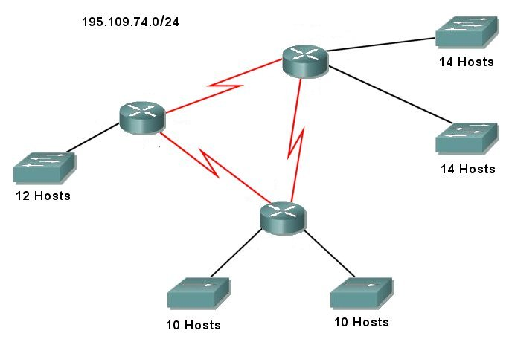
195.109.74.32 / 28
195.109.74.64 / 28
195.109.74.48 / 28
195.109.74.16 / 28
195.109.74.0 / 28
195.109.74.80 / 30
195.109.74.84 / 30
195.109.74.88 / 30
Solution - VLSM Exercise # 4

195.109.74.0 / 24
 | Network: | 1 | 1 | 0 | 0 | 0 | 0 | 1 | 1 | . | 0 | 1 | 1 | 0 | 1 | 1 | 0 | 1 | . | 0 | 1 | 0 | 0 | 1 | 0 | 1 | 0 | . | 0 | 0 | 0 | 0 | 0 | 0 | 0 | 0
 | Subnet Mask: | 1 | 1 | 1 | 1 | 1 | 1 | 1 | 1 | . | 1 | 1 | 1 | 1 | 1 | 1 | 1 | 1 | . | 1 | 1 | 1 | 1 | 1 | 1 | 1 | 1 | . | 0 | 0 | 0 | 0 | 0 | 0 | 0 | 0
 |  | Borrow 4 - 28 Network bits - 4 Host bits - Magic Number = 16
14 Hosts | 195.109.74.0 / 28 | 1 | 1 | 0 | 0 | 0 | 0 | 1 | 1 | . | 0 | 1 | 1 | 0 | 1 | 1 | 0 | 1 | . | 0 | 1 | 0 | 0 | 1 | 0 | 1 | 0 | . | 0 | 0 | 0 | 0 | 0 | 0 | 0 | 0
14 Hosts | 195.109.74.16 / 28 |  |  |  |  |  |  |  |  |  |  |  |  |  | • |  |  |  |  |  |  |  |  |  |  |  |  |  | 0 | 0 | 0 | 1
12 Hosts | 195.109.74.32 / 28 |  |  |  |  |  |  |  |  |  |  |  |  |  | • |  |  |  |  |  |  |  |  |  |  |  |  |  | 0 | 0 | 1 | 0
10 Hosts | 195.109.74.48 / 28 |  |  |  |  |  |  |  |  |  |  |  |  |  | • |  |  |  |  |  |  |  |  |  |  |  |  |  | 0 | 0 | 1 | 1
10 Hosts | 195.109.74.64 / 28 |  |  |  |  |  |  |  |  |  |  |  |  |  | • |  |  |  |  |  |  |  |  |  |  |  |  |  | 0 | 1 | 0 | 0
 | 195.109.74.80 / 28 |  |  |  |  |  |  |  |  |  |  |  |  |  | • |  |  |  |  |  |  |  |  |  |  |  |  |  | 0 | 1 | 0 | 1
 | 195.109.74.96 / 28 |  |  |  |  |  |  |  |  |  |  |  |  |  | • |  |  |  |  |  |  |  |  |  |  |  |  |  | 0 | 1 | 1 | 0
 | • |  |  |  |  |  |  |  |  |  |  |  |  |  | • |  |  |  |  |  |  |  |  |  |  |  |  |  |  | •
 | • |  |  |  |  |  |  |  |  |  |  |  |  |  | • |  |  |  |  |  |  |  |  |  |  |  |  |  |  | •
 | • |  |  |  |  |  |  |  |  |  |  |  |  |  | • |  |  |  |  |  |  |  |  |  |  |  |  |  |  | •
 | 195.109.74.240 / 28 | 1 | 1 | 0 | 0 | 0 | 0 | 1 | 1 | . | 0 | 1 | 1 | 0 | 1 | 1 | 0 | 1 | . | 0 | 1 | 0 | 0 | 1 | 0 | 1 | 0 | . | 1 | 1 | 1 | 1 | 0 | 0 | 0 | 0
 | Subnet Mask: | 1 | 1 | 1 | 1 | 1 | 1 | 1 | 1 | . | 1 | 1 | 1 | 1 | 1 | 1 | 1 | 1 | . | 1 | 1 | 1 | 1 | 1 | 1 | 1 | 1 | . | 1 | 1 | 1 | 1 | 0 | 0 | 0 | 0
 |  | Borrow 2 More - 30 Network bits - 2 Host bits - Magic Number = 4
2 Hosts | 195.109.74.80 / 30 | 1 | 1 | 0 | 0 | 0 | 0 | 1 | 1 | . | 0 | 1 | 1 | 0 | 1 | 1 | 0 | 1 | . | 0 | 1 | 0 | 0 | 1 | 0 | 1 | 0 | . | 0 | 1 | 0 | 1 | 0 | 0 | 0 | 0
2 Hosts | 195.109.74.84 / 30 |  |  |  |  |  |  |  |  |  |  |  |  |  | • |  |  |  |  |  |  |  |  |  |  |  |  |  |  |  |  |  | 0 | 1
2 Hosts | 195.109.74.88 / 30 |  |  |  |  |  |  |  |  |  |  |  |  |  | • |  |  |  |  |  |  |  |  |  |  |  |  |  |  |  |  |  | 1 | 0
 | 195.109.74.92 / 30 | 1 | 1 | 0 | 0 | 0 | 0 | 1 | 1 | . | 0 | 1 | 1 | 0 | 1 | 1 | 0 | 1 | . | 0 | 1 | 0 | 0 | 1 | 0 | 1 | 0 | . | 0 | 1 | 0 | 1 | 1 | 1 | 0 | 0
 | Subnet Mask: | 1 | 1 | 1 | 1 | 1 | 1 | 1 | 1 | . | 1 | 1 | 1 | 1 | 1 | 1 | 1 | 1 | . | 1 | 1 | 1 | 1 | 1 | 1 | 1 | 1 | . | 1 | 1 | 1 | 1 | 1 | 1 | 0 | 0

Solution - VLSM Exercise # 5

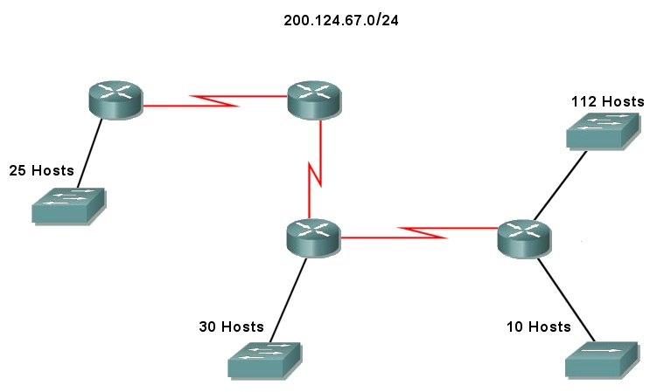
200.124.67.160 / 27
200.124.67.208 / 30
200.124.67.212 / 30
200.124.67.128 / 27
200.124.67.216 / 30
200.124.67.192 / 28
200.124.67.0 / 25
Solution - VLSM Exercise # 5

200.124.67.0 / 24
 | Network: | 1 | 1 | 0 | 0 | 1 | 0 | 0 | 0 | . | 0 | 1 | 1 | 1 | 1 | 1 | 0 | 0 | . | 0 | 1 | 0 | 0 | 0 | 0 | 1 | 1 | . | 0 | 0 | 0 | 0 | 0 | 0 | 0 | 0
 | Subnet Mask: | 1 | 1 | 1 | 1 | 1 | 1 | 1 | 1 | . | 1 | 1 | 1 | 1 | 1 | 1 | 1 | 1 | . | 1 | 1 | 1 | 1 | 1 | 1 | 1 | 1 | . | 0 | 0 | 0 | 0 | 0 | 0 | 0 | 0
 |  | Borrow 1 - 25 Network bits - 7 Host bits - Magic Number = 128
112 Hosts | 200.124.67.0 / 25 | 1 | 1 | 0 | 0 | 1 | 0 | 0 | 0 | . | 0 | 1 | 1 | 1 | 1 | 1 | 0 | 0 | . | 0 | 1 | 0 | 0 | 0 | 0 | 1 | 1 | . | 0 | 0 | 0 | 0 | 0 | 0 | 0 | 0
 | 200.124.67.128 / 25 |  |  |  |  |  |  |  |  |  |  |  |  |  |  |  |  |  |  |  |  |  |  |  |  |  |  |  | 1
 | Subnet Mask: | 1 | 1 | 1 | 1 | 1 | 1 | 1 | 1 | . | 1 | 1 | 1 | 1 | 1 | 1 | 1 | 1 | . | 1 | 1 | 1 | 1 | 1 | 1 | 1 | 1 | . | 1 | 0 | 0 | 0 | 0 | 0 | 0 | 0
 |  | Borrow 2 More - 27 Network bits - 5 Host bits - Magic Number = 32
30 Hosts | 200.124.67.128 / 27 | 1 | 1 | 0 | 0 | 1 | 0 | 0 | 0 | . | 0 | 1 | 1 | 1 | 1 | 1 | 0 | 0 | . | 0 | 1 | 0 | 0 | 0 | 0 | 1 | 1 | . | 1 | 0 | 0 | 0 | 0 | 0 | 0 | 0
25 Hosts | 200.124.67.160 / 27 |  |  |  |  |  |  |  |  |  |  |  |  |  | • |  |  |  |  |  |  |  |  |  |  |  |  |  |  | 0 | 1
 | 200.124.67.192 / 27 |  |  |  |  |  |  |  |  |  |  |  |  |  | • |  |  |  |  |  |  |  |  |  |  |  |  |  |  | 1 | 0
 | 200.124.67.224 / 27 | 1 | 1 | 0 | 0 | 1 | 0 | 0 | 0 | . | 0 | 1 | 1 | 1 | 1 | 1 | 0 | 0 | . | 0 | 1 | 0 | 0 | 0 | 0 | 1 | 1 | . | 1 | 1 | 1 | 0 | 0 | 0 | 0 | 0
 | Subnet Mask: | 1 | 1 | 1 | 1 | 1 | 1 | 1 | 1 | . | 1 | 1 | 1 | 1 | 1 | 1 | 1 | 1 | . | 1 | 1 | 1 | 1 | 1 | 1 | 1 | 1 | . | 1 | 1 | 1 | 0 | 0 | 0 | 0 | 0
 |  | Borrow 1 More - 28 Network bits - 4 Host bits - Magic Number = 16
10 Hosts | 200.124.67.192 / 28 | 1 | 1 | 0 | 0 | 1 | 0 | 0 | 0 | . | 0 | 1 | 1 | 1 | 1 | 1 | 0 | 0 | . | 0 | 1 | 0 | 0 | 0 | 0 | 1 | 1 | . | 1 | 1 | 0 | 0 | 0 | 0 | 0 | 0
 | 200.124.67.208 / 28 |  |  |  |  |  |  |  |  |  |  |  |  |  |  |  |  |  |  |  |  |  |  |  |  |  |  |  |  |  |  | 1
 | Subnet Mask: | 1 | 1 | 1 | 1 | 1 | 1 | 1 | 1 | . | 1 | 1 | 1 | 1 | 1 | 1 | 1 | 1 | . | 1 | 1 | 1 | 1 | 1 | 1 | 1 | 1 | . | 1 | 1 | 1 | 1 | 0 | 0 | 0 | 0
 |  | Borrow 2 More - 30 Network bits - 2 Host bits - Magic Number = 4
2 Hosts | 200.124.67.208 / 30 | 1 | 1 | 0 | 0 | 1 | 0 | 0 | 0 | . | 0 | 1 | 1 | 1 | 1 | 1 | 0 | 0 | . | 0 | 1 | 0 | 0 | 0 | 0 | 1 | 1 | . | 0 | 1 | 0 | 1 | 0 | 0 | 0 | 0
2 Hosts | 200.124.67.212 / 30 |  |  |  |  |  |  |  |  |  |  |  |  |  | • |  |  |  |  |  |  |  |  |  |  |  |  |  |  |  |  |  | 0 | 1
2 Hosts | 200.124.67.216 / 30 |  |  |  |  |  |  |  |  |  |  |  |  |  | • |  |  |  |  |  |  |  |  |  |  |  |  |  |  |  |  |  | 1 | 0
 | 200.124.67.220 / 30 | 1 | 1 | 0 | 0 | 1 | 0 | 0 | 0 | . | 0 | 1 | 1 | 1 | 1 | 1 | 0 | 0 | . | 0 | 1 | 0 | 0 | 0 | 0 | 1 | 1 | . | 0 | 1 | 0 | 1 | 1 | 1 | 0 | 0
 | Subnet Mask: | 1 | 1 | 1 | 1 | 1 | 1 | 1 | 1 | . | 1 | 1 | 1 | 1 | 1 | 1 | 1 | 1 | . | 1 | 1 | 1 | 1 | 1 | 1 | 1 | 1 | . | 1 | 1 | 1 | 1 | 1 | 1 | 0 | 0

Solution - VLSM Exercise # 6

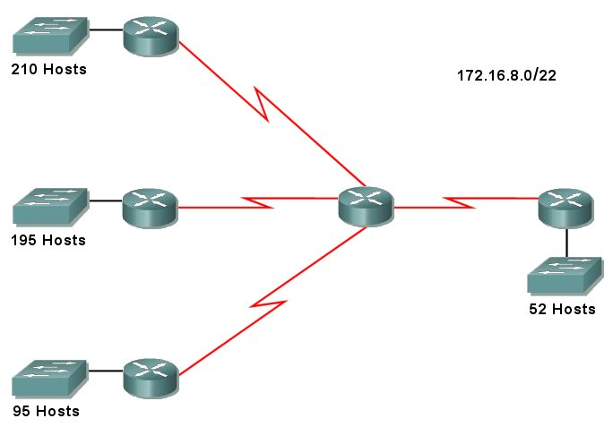
172.16.8.0 / 24
172.16.9.0 / 24
172.16.10.0 / 25
172.16.10.128 / 26
172.16.10.192 / 30
172.16.10.196 / 30
172.16.10.200 / 30
172.16.10.204 / 30
Solution - VLSM Exercise # 6

172.16.8.0 / 22
 | Network: | 1 | 0 | 1 | 0 | 1 | 1 | 0 | 0 | . | 0 | 0 | 0 | 0 | 1 | 0 | 0 | 0 | . | 0 | 0 | 0 | 0 | 0 | 1 | 0 | 0 | . | 0 | 0 | 0 | 0 | 0 | 0 | 0 | 0
 | Subnet Mask: | 1 | 1 | 1 | 1 | 1 | 1 | 1 | 1 | . | 1 | 1 | 1 | 1 | 1 | 1 | 1 | 1 | . | 1 | 1 | 1 | 1 | 1 | 1 | 0 | 0 | . | 0 | 0 | 0 | 0 | 0 | 0 | 0 | 0
 |  | Borrow 2 - 24 Network bits - 8 Host bits - Magic Number = 256
210 Hosts | 172.16.8.0 / 24 | 1 | 0 | 1 | 0 | 1 | 1 | 0 | 0 | . | 0 | 0 | 0 | 0 | 1 | 0 | 0 | 0 | . | 0 | 0 | 0 | 0 | 0 | 1 | 0 | 0 | . | 0 | 0 | 0 | 0 | 0 | 0 | 0 | 0
195 Hosts | 172.16.9.0 / 24 |  |  |  |  |  |  |  |  |  |  |  |  |  | • |  |  |  |  |  |  |  |  |  |  | 0 | 1 |  |  |  |  | •
 | 172.16.10.0 / 24 |  |  |  |  |  |  |  |  |  |  |  |  |  | • |  |  |  |  |  |  |  |  |  |  | 1 | 0 |  |  |  |  | •
 | 172.16.11.0 / 24 | 1 | 0 | 1 | 0 | 1 | 1 | 0 | 0 | . | 0 | 0 | 0 | 0 | 1 | 0 | 0 | 0 | . | 0 | 0 | 0 | 0 | 0 | 1 | 1 | 1 | . | 0 | 0 | 0 | 0 | 0 | 0 | 0 | 0
 | Subnet Mask: | 1 | 1 | 1 | 1 | 1 | 1 | 1 | 1 | . | 1 | 1 | 1 | 1 | 1 | 1 | 1 | 1 | . | 1 | 1 | 1 | 1 | 1 | 1 | 1 | 1 | . | 0 | 0 | 0 | 0 | 0 | 0 | 0 | 0
 |  | Borrow 1 More - 25 Network bits - 7 Host bits - Magic Number = 128
95 Hosts | 172.16.10.0 / 25 | 1 | 0 | 1 | 0 | 1 | 1 | 0 | 0 | . | 0 | 0 | 0 | 0 | 1 | 0 | 0 | 0 | . | 0 | 0 | 0 | 0 | 0 | 1 | 1 | 0 | . | 0 | 0 | 0 | 0 | 0 | 0 | 0 | 0
 | 172.16.10.128 / 25 |  |  |  |  |  |  |  |  |  |  |  |  |  |  |  |  |  |  |  |  |  |  |  |  |  |  |  | 1
 | Subnet Mask: | 1 | 1 | 1 | 1 | 1 | 1 | 1 | 1 | . | 1 | 1 | 1 | 1 | 1 | 1 | 1 | 1 | . | 1 | 1 | 1 | 1 | 1 | 1 | 1 | 1 | . | 1 | 0 | 0 | 0 | 0 | 0 | 0 | 0
 |  | Borrow 1 More - 26 Network bits - 6 Host bits - Magic Number = 64
52 Hosts | 172.16.10.128 / 26 | 1 | 0 | 1 | 0 | 1 | 1 | 0 | 0 | . | 0 | 0 | 0 | 0 | 1 | 0 | 0 | 0 | . | 0 | 0 | 0 | 0 | 0 | 1 | 1 | 0 | . | 1 | 0 | 0 | 0 | 0 | 0 | 0 | 0
 | 172.16.10.192 / 26 |  |  |  |  |  |  |  |  |  |  |  |  |  |  |  |  |  |  |  |  |  |  |  |  |  |  |  |  | 1
 | Subnet Mask: | 1 | 1 | 1 | 1 | 1 | 1 | 1 | 1 | . | 1 | 1 | 1 | 1 | 1 | 1 | 1 | 1 | . | 1 | 1 | 1 | 1 | 1 | 1 | 1 | 1 | . | 1 | 1 | 0 | 0 | 0 | 0 | 0 | 0
 |  | Borrow 4 More - 30 Network bits - 2 Host bits - Magic Number = 4
2 Hosts | 172.16.10.192 / 30 | 1 | 0 | 1 | 0 | 1 | 1 | 0 | 0 | . | 0 | 0 | 0 | 0 | 1 | 0 | 0 | 0 | . | 0 | 0 | 0 | 0 | 0 | 1 | 1 | 0 | . | 1 | 1 | 0 | 0 | 0 | 0 | 0 | 0
2 Hosts | 172.16.10.196 / 30 |  |  |  |  |  |  |  |  |  |  |  |  |  | • |  |  |  |  |  |  |  |  |  |  |  |  |  |  |  | 0 | 0 | 0 | 1
2 Hosts | 172.16.10.200 / 30 |  |  |  |  |  |  |  |  |  |  |  |  |  | • |  |  |  |  |  |  |  |  |  |  |  |  |  |  |  | 0 | 0 | 1 | 0
2 Hosts | 172.16.10.204 / 30 |  |  |  |  |  |  |  |  |  |  |  |  |  | • |  |  |  |  |  |  |  |  |  |  |  |  |  |  |  | 0 | 0 | 1 | 1
 | • |  |  |  |  |  |  |  |  |  |  |  |  |  | • |  |  |  |  |  |  |  |  |  |  |  |  |  |  |  |  | •
 | • |  |  |  |  |  |  |  |  |  |  |  |  |  | • |  |  |  |  |  |  |  |  |  |  |  |  |  |  |  |  | •
 | 172.16.10.252 / 30 | 1 | 0 | 1 | 0 | 1 | 1 | 0 | 0 | . | 0 | 0 | 0 | 0 | 1 | 0 | 0 | 0 | . | 0 | 0 | 0 | 0 | 0 | 1 | 1 | 0 | . | 1 | 1 | 1 | 1 | 1 | 1 | 0 | 0
 | Subnet Mask: | 1 | 1 | 1 | 1 | 1 | 1 | 1 | 1 | . | 1 | 1 | 1 | 1 | 1 | 1 | 1 | 1 | . | 1 | 1 | 1 | 1 | 1 | 1 | 1 | 1 | . | 1 | 1 | 1 | 1 | 1 | 1 | 0 | 0

Solution - VLSM Exercise # 7

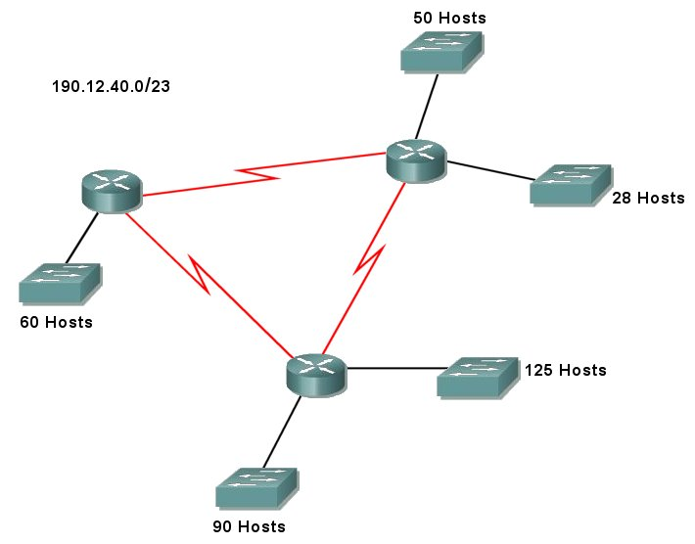
190.12.40.0 / 25
190.12.40.128 / 25
190.12.41.0 / 26
190.12.41.64 / 26
190.12.41.128 / 27
190.12.41.160 / 30
190.12.41.164 / 30
190.12.41.168 / 30
Solution - VLSM Exercise # 7

190.12.40.0 / 23
 | Network: | 1 | 0 | 1 | 1 | 1 | 1 | 1 | 0 | . | 0 | 0 | 0 | 0 | 1 | 1 | 0 | 0 | . | 0 | 0 | 1 | 0 | 0 | 1 | 0 | 0 | . | 0 | 0 | 0 | 0 | 0 | 0 | 0 | 0
 | Subnet Mask: | 1 | 1 | 1 | 1 | 1 | 1 | 1 | 1 | . | 1 | 1 | 1 | 1 | 1 | 1 | 1 | 1 | . | 1 | 1 | 1 | 1 | 1 | 1 | 1 | 0 | . | 0 | 0 | 0 | 0 | 0 | 0 | 0 | 0
 |  | Borrow 2 - 25 Network bits - 7 Host bits - Magic Number = 128
125 Hosts | 190.12.40.0 / 25 | 1 | 0 | 1 | 1 | 1 | 1 | 1 | 0 | . | 0 | 0 | 0 | 0 | 1 | 1 | 0 | 0 | . | 0 | 0 | 1 | 0 | 0 | 1 | 0 | 0 | . | 0 | 0 | 0 | 0 | 0 | 0 | 0 | 0
90 Hosts | 190.12.40.128 / 25 |  |  |  |  |  |  |  |  |  |  |  |  |  | • |  |  |  |  |  |  |  |  |  |  |  | 0 | . | 1
 | 190.12.41.0 / 25 |  |  |  |  |  |  |  |  |  |  |  |  |  | • |  |  |  |  |  |  |  |  |  |  |  | 1 | . | 0
 | 190.12.41.128 / 25 | 1 | 0 | 1 | 1 | 1 | 1 | 1 | 0 | . | 0 | 0 | 0 | 0 | 1 | 1 | 0 | 0 | . | 0 | 0 | 1 | 0 | 0 | 1 | 0 | 1 | . | 1 | 0 | 0 | 0 | 0 | 0 | 0 | 0
 | Subnet Mask: | 1 | 1 | 1 | 1 | 1 | 1 | 1 | 1 | . | 1 | 1 | 1 | 1 | 1 | 1 | 1 | 1 | . | 1 | 1 | 1 | 1 | 1 | 1 | 1 | 1 | . | 1 | 0 | 0 | 0 | 0 | 0 | 0 | 0
 |  | Borrow 1 More - 26 Network bits - 6 Host bits - Magic Number = 64
60 Hosts | 190.12.41.0 / 26 | 1 | 0 | 1 | 1 | 1 | 1 | 1 | 0 | . | 0 | 0 | 0 | 0 | 1 | 1 | 0 | 0 | . | 0 | 0 | 1 | 0 | 0 | 1 | 0 | 1 | . | 0 | 0 | 0 | 0 | 0 | 0 | 0 | 0
50 Hosts | 190.12.41.64 / 26 |  |  |  |  |  |  |  |  |  |  |  |  |  |  |  |  |  |  |  |  |  |  |  |  |  |  |  |  | 1
 | Subnet Mask: | 1 | 1 | 1 | 1 | 1 | 1 | 1 | 1 | . | 1 | 1 | 1 | 1 | 1 | 1 | 1 | 1 | . | 1 | 1 | 1 | 1 | 1 | 1 | 1 | 1 | . | 1 | 1 | 0 | 0 | 0 | 0 | 0 | 0
 |  | Borrow 1 More - 27 Network bits - 5 Host bits - Magic Number = 32
28 Hosts | 190.12.41.128 / 27 | 1 | 0 | 1 | 1 | 1 | 1 | 1 | 0 | . | 0 | 0 | 0 | 0 | 1 | 1 | 0 | 0 | . | 0 | 0 | 1 | 0 | 0 | 1 | 0 | 1 | . | 1 | 0 | 0 | 0 | 0 | 0 | 0 | 0
 | 190.12.41.160 / 27 |  |  |  |  |  |  |  |  |  |  |  |  |  |  |  |  |  |  |  |  |  |  |  |  |  |  |  |  |  | 1
 | Subnet Mask: | 1 | 1 | 1 | 1 | 1 | 1 | 1 | 1 | . | 1 | 1 | 1 | 1 | 1 | 1 | 1 | 1 | . | 1 | 1 | 1 | 1 | 1 | 1 | 1 | 1 | . | 1 | 1 | 1 | 0 | 0 | 0 | 0 | 0
 |  | Borrow 3 More - 30 Network bits - 2 Host bits - Magic Number = 4
2 Hosts | 190.12.41.160 / 30 | 1 | 0 | 1 | 1 | 1 | 1 | 1 | 0 | . | 0 | 0 | 0 | 0 | 1 | 1 | 0 | 0 | . | 0 | 0 | 1 | 0 | 0 | 1 | 0 | 1 | . | 1 | 0 | 1 | 0 | 0 | 0 | 0 | 0
2 Hosts | 190.12.41.164 / 30 |  |  |  |  |  |  |  |  |  |  |  |  |  | • |  |  |  |  |  |  |  |  |  |  |  |  |  |  |  |  | 0 | 0 | 1
2 Hosts | 190.12.41.168 / 30 |  |  |  |  |  |  |  |  |  |  |  |  |  | • |  |  |  |  |  |  |  |  |  |  |  |  |  |  |  |  | 0 | 1 | 0
 | 190.12.41.172 / 30 |  |  |  |  |  |  |  |  |  |  |  |  |  | • |  |  |  |  |  |  |  |  |  |  |  |  |  |  |  |  | 0 | 1 | 1
 | • |  |  |  |  |  |  |  |  |  |  |  |  |  | • |  |  |  |  |  |  |  |  |  |  |  |  |  |  |  |  |  | •
 | • |  |  |  |  |  |  |  |  |  |  |  |  |  | • |  |  |  |  |  |  |  |  |  |  |  |  |  |  |  |  |  | •
 | 190.12.41.252 / 30 | 1 | 0 | 1 | 1 | 1 | 1 | 1 | 0 | . | 0 | 0 | 0 | 0 | 1 | 1 | 0 | 0 | . | 0 | 0 | 1 | 0 | 0 | 1 | 0 | 1 | . | 1 | 0 | 1 | 1 | 1 | 1 | 0 | 0
 | Subnet Mask: | 1 | 1 | 1 | 1 | 1 | 1 | 1 | 1 | . | 1 | 1 | 1 | 1 | 1 | 1 | 1 | 1 | . | 1 | 1 | 1 | 1 | 1 | 1 | 1 | 1 | . | 1 | 1 | 1 | 1 | 1 | 1 | 0 | 0

Solution - VLSM Exercise # 8

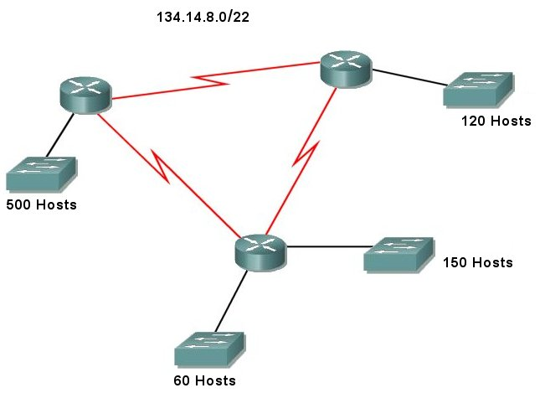
134.14.8.0 / 23
134.14.10.0 / 24
134.14.11.0 / 25
134.14.11.128 / 26
134.14.11.192 / 30
134.14.11.196 / 30
134.14.11.200 / 30
Solution - VLSM Exercise # 8

134.14.8.0 / 22
 | Network: | 1 | 0 | 0 | 0 | 0 | 1 | 1 | 0 | . | 0 | 0 | 0 | 0 | 1 | 1 | 1 | 0 | . | 0 | 0 | 0 | 0 | 1 | 0 | 0 | 0 | . | 0 | 0 | 0 | 0 | 0 | 0 | 0 | 0
 | Subnet Mask: | 1 | 1 | 1 | 1 | 1 | 1 | 1 | 1 | . | 1 | 1 | 1 | 1 | 1 | 1 | 1 | 1 | . | 1 | 1 | 1 | 1 | 1 | 1 | 0 | 0 | . | 0 | 0 | 0 | 0 | 0 | 0 | 0 | 0
 |  | Borrow 1 - 23 Network bits - 9 Host bits - Magic Number = 2
500 Hosts | 134.14.8.0 / 23 | 1 | 0 | 0 | 0 | 0 | 1 | 1 | 0 | . | 0 | 0 | 0 | 0 | 1 | 1 | 1 | 0 | . | 0 | 0 | 0 | 0 | 1 | 0 | 0 | 0 | . | 0 | 0 | 0 | 0 | 0 | 0 | 0 | 0
 | 134.14.10.0 / 23 |  |  |  |  |  |  |  |  |  |  |  |  |  |  |  |  |  |  |  |  |  |  |  |  | 1
 | Subnet Mask: | 1 | 1 | 1 | 1 | 1 | 1 | 1 | 1 | . | 1 | 1 | 1 | 1 | 1 | 1 | 1 | 1 | . | 1 | 1 | 1 | 1 | 1 | 1 | 1 | 0 | . | 0 | 0 | 0 | 0 | 0 | 0 | 0 | 0
 |  | Borrow 1 More - 24 Network bits - 8 Host bits - Magic Number = 256
150 Hosts | 134.14.10.0 / 24 | 1 | 0 | 0 | 0 | 0 | 1 | 1 | 0 | . | 0 | 0 | 0 | 0 | 1 | 1 | 1 | 0 | . | 0 | 0 | 0 | 0 | 1 | 0 | 1 | 0 | . | 0 | 0 | 0 | 0 | 0 | 0 | 0 | 0
 | 134.14.11.0 / 24 |  |  |  |  |  |  |  |  |  |  |  |  |  |  |  |  |  |  |  |  |  |  |  |  |  | 1
 | Subnet Mask: | 1 | 1 | 1 | 1 | 1 | 1 | 1 | 1 | . | 1 | 1 | 1 | 1 | 1 | 1 | 1 | 1 | . | 1 | 1 | 1 | 1 | 1 | 1 | 1 | 1 | . | 0 | 0 | 0 | 0 | 0 | 0 | 0 | 0
 |  | Borrow 1 More - 25 Network bits - 7 Host bits - Magic Number = 128
120 Hosts | 134.14.11.0 / 25 | 1 | 0 | 0 | 0 | 0 | 1 | 1 | 0 | . | 0 | 0 | 0 | 0 | 1 | 1 | 1 | 0 | . | 0 | 0 | 0 | 0 | 1 | 0 | 1 | 1 | . | 0 | 0 | 0 | 0 | 0 | 0 | 0 | 0
 | 134.14.11.128 / 25 |  |  |  |  |  |  |  |  |  |  |  |  |  |  |  |  |  |  |  |  |  |  |  |  |  |  |  | 1
 | Subnet Mask: | 1 | 1 | 1 | 1 | 1 | 1 | 1 | 1 | . | 1 | 1 | 1 | 1 | 1 | 1 | 1 | 1 | . | 1 | 1 | 1 | 1 | 1 | 1 | 1 | 1 | . | 1 | 0 | 0 | 0 | 0 | 0 | 0 | 0
 |  | Borrow 1 More - 26 Network bits - 6 Host bits - Magic Number = 64
60 Hosts | 134.14.11.128 / 26 | 1 | 0 | 0 | 0 | 0 | 1 | 1 | 0 | . | 0 | 0 | 0 | 0 | 1 | 1 | 1 | 0 | . | 0 | 0 | 0 | 0 | 1 | 0 | 1 | 1 | . | 1 | 0 | 0 | 0 | 0 | 0 | 0 | 0
 | 134.14.11.192 / 26 |  |  |  |  |  |  |  |  |  |  |  |  |  |  |  |  |  |  |  |  |  |  |  |  |  |  |  |  | 1
 | Subnet Mask: | 1 | 1 | 1 | 1 | 1 | 1 | 1 | 1 | . | 1 | 1 | 1 | 1 | 1 | 1 | 1 | 1 | . | 1 | 1 | 1 | 1 | 1 | 1 | 1 | 1 | . | 1 | 1 | 0 | 0 | 0 | 0 | 0 | 0
Next Page
Solution - VLSM Exercise # 8

 |  | Borrow 4 More - 30 Network bits - 2 Host bits - Magic Number = 4
2 Hosts | 134.14.11.192 / 30 | 1 | 0 | 0 | 0 | 0 | 1 | 1 | 0 | . | 0 | 0 | 0 | 0 | 1 | 1 | 1 | 0 | . | 0 | 0 | 0 | 0 | 1 | 0 | 0 | 0 | . | 1 | 1 | 0 | 0 | 0 | 0 | 0 | 0
2 Hosts | 134.14.11.196 / 30 |  |  |  |  |  |  |  |  |  |  |  |  |  | • |  |  |  |  |  |  |  |  |  |  |  |  |  |  |  | 0 | 0 | 0 | 1
2 Hosts | 134.14.11.200 / 30 |  |  |  |  |  |  |  |  |  |  |  |  |  | • |  |  |  |  |  |  |  |  |  |  |  |  |  |  |  | 0 | 0 | 1 | 0
 | 134.14.11.204 / 30 |  |  |  |  |  |  |  |  |  |  |  |  |  | • |  |  |  |  |  |  |  |  |  |  |  |  |  |  |  | 0 | 0 | 1 | 1
 | • |  |  |  |  |  |  |  |  |  |  |  |  |  | • |  |  |  |  |  |  |  |  |  |  |  |  |  |  |  |  | •
 | • |  |  |  |  |  |  |  |  |  |  |  |  |  | • |  |  |  |  |  |  |  |  |  |  |  |  |  |  |  |  | •
 | 134.14.11.252 / 30 | 1 | 0 | 0 | 0 | 0 | 1 | 1 | 0 | . | 0 | 0 | 0 | 0 | 1 | 1 | 1 | 0 | . | 0 | 0 | 0 | 0 | 1 | 0 | 0 | 0 | . | 1 | 1 | 1 | 1 | 1 | 1 | 0 | 0
 | Subnet Mask: | 1 | 1 | 1 | 1 | 1 | 1 | 1 | 1 | . | 1 | 1 | 1 | 1 | 1 | 1 | 1 | 1 | . | 1 | 1 | 1 | 1 | 1 | 1 | 1 | 1 | . | 1 | 1 | 1 | 1 | 1 | 1 | 0 | 0

Solution - VLSM Exercise # 9

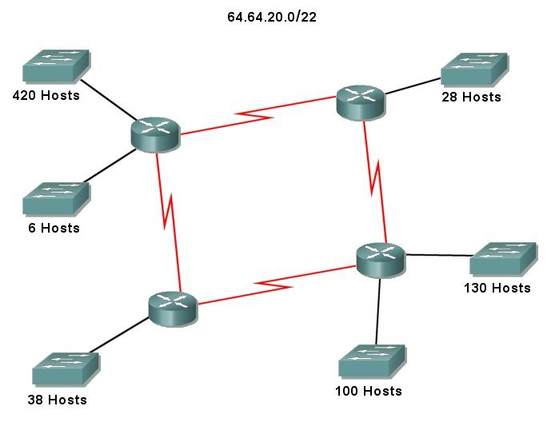
64.64.20.0 / 23
64.64.22.0 / 24
64.64.23.0 / 25
64.64.23.128 / 26
64.64.23.192 / 27
64.64.23.224 / 29
64.64.23.232 / 30
64.64.23.236 / 30
64.64.23.240 / 30
64.64.23.244 / 30
64.64.20.0 / 23
64.64.22.0 / 24
64.64.23.0 / 25
64.64.23.128 / 26
64.64.23.192 / 27
64.64.23.224 / 29
64.64.23.232 / 30
64.64.23.236 / 30
64.64.23.240 / 30
64.64.23.244 / 30
Solution - VLSM Exercise # 9

64.64.20.0 / 22
 | Network: | 0 | 1 | 0 | 0 | 0 | 0 | 0 | 0 | . | 0 | 1 | 0 | 0 | 0 | 0 | 0 | 0 | . | 0 | 0 | 0 | 1 | 0 | 1 | 0 | 0 | . | 0 | 0 | 0 | 0 | 0 | 0 | 0 | 0
 | Subnet Mask: | 1 | 1 | 1 | 1 | 1 | 1 | 1 | 1 | . | 1 | 1 | 1 | 1 | 1 | 1 | 1 | 1 | . | 1 | 1 | 1 | 1 | 1 | 1 | 0 | 0 | . | 0 | 0 | 0 | 0 | 0 | 0 | 0 | 0
 |  | Borrow 1 - 23 Network bits - 9 Host bits - Magic Number = 2
420 Hosts | 64.64.20.0 / 23 | 0 | 1 | 0 | 0 | 0 | 0 | 0 | 0 | . | 0 | 1 | 0 | 0 | 0 | 0 | 0 | 0 | . | 0 | 0 | 0 | 1 | 0 | 1 | 0 | 0 | . | 0 | 0 | 0 | 0 | 0 | 0 | 0 | 0
 | 64.64.22.0 / 23 |  |  |  |  |  |  |  |  |  |  |  |  |  |  |  |  |  |  |  |  |  |  |  |  | 1
 | Subnet Mask: | 1 | 1 | 1 | 1 | 1 | 1 | 1 | 1 | . | 1 | 1 | 1 | 1 | 1 | 1 | 1 | 1 | . | 1 | 1 | 1 | 1 | 1 | 1 | 1 | 0 | . | 0 | 0 | 0 | 0 | 0 | 0 | 0 | 0
 |  | Borrow 1 More - 24 Network bits - 8 Host bits - Magic Number = 256
130 Hosts | 64.64.22.0 / 24 | 0 | 1 | 0 | 0 | 0 | 0 | 0 | 0 | . | 0 | 1 | 0 | 0 | 0 | 0 | 0 | 0 | . | 0 | 0 | 0 | 1 | 0 | 1 | 1 | 0 | . | 0 | 0 | 0 | 0 | 0 | 0 | 0 | 0
 | 64.64.23.0 / 24 |  |  |  |  |  |  |  |  |  |  |  |  |  |  |  |  |  |  |  |  |  |  |  |  |  | 1
 | Subnet Mask: | 1 | 1 | 1 | 1 | 1 | 1 | 1 | 1 | . | 1 | 1 | 1 | 1 | 1 | 1 | 1 | 1 | . | 1 | 1 | 1 | 1 | 1 | 1 | 1 | 1 | . | 0 | 0 | 0 | 0 | 0 | 0 | 0 | 0
 |  | Borrow 1 More - 25 Network bits - 7 Host bits - Magic Number = 128
100 Hosts | 64.64.23.0 / 25 | 0 | 1 | 0 | 0 | 0 | 0 | 0 | 0 | . | 0 | 1 | 0 | 0 | 0 | 0 | 0 | 0 | . | 0 | 0 | 0 | 1 | 0 | 1 | 1 | 1 | . | 0 | 0 | 0 | 0 | 0 | 0 | 0 | 0
 | 64.64.23.128 / 25 |  |  |  |  |  |  |  |  |  |  |  |  |  |  |  |  |  |  |  |  |  |  |  |  |  |  |  | 1
 | Subnet Mask: | 1 | 1 | 1 | 1 | 1 | 1 | 1 | 1 | . | 1 | 1 | 1 | 1 | 1 | 1 | 1 | 1 | . | 1 | 1 | 1 | 1 | 1 | 1 | 1 | 1 | . | 1 | 0 | 0 | 0 | 0 | 0 | 0 | 0
 |  | Borrow 1 More - 26 Network bits - 6 Host bits - Magic Number = 64
38 Hosts | 64.64.23.128 / 26 | 0 | 1 | 0 | 0 | 0 | 0 | 0 | 0 | . | 0 | 1 | 0 | 0 | 0 | 0 | 0 | 0 | . | 0 | 0 | 0 | 1 | 0 | 1 | 0 | 0 | . | 1 | 0 | 0 | 0 | 0 | 0 | 0 | 0
 | 64.64.23.192 / 26 |  |  |  |  |  |  |  |  |  |  |  |  |  |  |  |  |  |  |  |  |  |  |  |  |  |  |  |  | 1
 | Subnet Mask: | 1 | 1 | 1 | 1 | 1 | 1 | 1 | 1 | . | 1 | 1 | 1 | 1 | 1 | 1 | 1 | 1 | . | 1 | 1 | 1 | 1 | 1 | 1 | 1 | 1 | . | 1 | 1 | 0 | 0 | 0 | 0 | 0 | 0
 |  | Borrow 1 More - 27 Network bits - 5 Host bits - Magic Number = 32
28 Hosts | 64.64.23.192 / 27 | 0 | 1 | 0 | 0 | 0 | 0 | 0 | 0 | . | 0 | 1 | 0 | 0 | 0 | 0 | 0 | 0 | . | 0 | 0 | 0 | 1 | 0 | 1 | 0 | 0 | . | 1 | 1 | 0 | 0 | 0 | 0 | 0 | 0
 | 64.64.23.224 / 27 |  |  |  |  |  |  |  |  |  |  |  |  |  |  |  |  |  |  |  |  |  |  |  |  |  |  |  |  |  | 1
 | Subnet Mask: | 1 | 1 | 1 | 1 | 1 | 1 | 1 | 1 | . | 1 | 1 | 1 | 1 | 1 | 1 | 1 | 1 | . | 1 | 1 | 1 | 1 | 1 | 1 | 1 | 1 | . | 1 | 1 | 1 | 0 | 0 | 0 | 0 | 0
Next Page
Solution - VLSM Exercise # 9

 |  | Borrow 2 More - 29 Network bits - 3 Host bits - Magic Number = 8
6 Hosts | 64.64.23.224 / 29 | 0 | 1 | 0 | 0 | 0 | 0 | 0 | 0 | . | 0 | 1 | 0 | 0 | 0 | 0 | 0 | 0 | . | 0 | 0 | 0 | 1 | 0 | 1 | 0 | 0 | . | 1 | 1 | 1 | 0 | 0 | 0 | 0 | 0
 | 64.64.23.232 / 29 |  |  |  |  |  |  |  |  |  |  |  |  |  | • |  |  |  |  |  |  |  |  |  |  |  |  |  |  |  |  | 0 | 1
 | 64.64.23.240 / 29 |  |  |  |  |  |  |  |  |  |  |  |  |  | • |  |  |  |  |  |  |  |  |  |  |  |  |  |  |  |  | 1 | 0
 | 64.64.23.248 / 29 | 0 | 1 | 0 | 0 | 0 | 0 | 0 | 0 | . | 0 | 1 | 0 | 0 | 0 | 0 | 0 | 0 | . | 0 | 0 | 0 | 1 | 0 | 1 | 0 | 0 | . | 1 | 1 | 1 | 1 | 1 | 0 | 0 | 0
 | Subnet Mask: | 1 | 1 | 1 | 1 | 1 | 1 | 1 | 1 | . | 1 | 1 | 1 | 1 | 1 | 1 | 1 | 1 | . | 1 | 1 | 1 | 1 | 1 | 1 | 1 | 1 | . | 1 | 1 | 1 | 1 | 1 | 0 | 0 | 0
 |  | Borrow 1 More - 30 Network bits - 2 Host bits - Magic Number = 4
2 Hosts | 64.64.23.232 / 30 | 0 | 1 | 0 | 0 | 0 | 0 | 0 | 0 | . | 0 | 1 | 0 | 0 | 0 | 0 | 0 | 0 | . | 0 | 0 | 0 | 1 | 0 | 1 | 0 | 0 | . | 1 | 1 | 1 | 0 | 1 | 0 | 0 | 0
2 Hosts | 64.64.23.236 / 30 |  |  |  |  |  |  |  |  |  |  |  |  |  |  |  |  |  |  |  |  |  |  |  |  |  |  |  |  |  |  |  |  | 1
 | Subnet Mask: | 1 | 1 | 1 | 1 | 1 | 1 | 1 | 1 | . | 1 | 1 | 1 | 1 | 1 | 1 | 1 | 1 | . | 1 | 1 | 1 | 1 | 1 | 1 | 1 | 1 | . | 1 | 1 | 1 | 1 | 1 | 1 | 0 | 0
 |  | Borrow 1 More - 30 Network bits - 2 Host bits - Magic Number = 4
2 Hosts | 64.64.23.240 / 30 | 0 | 1 | 0 | 0 | 0 | 0 | 0 | 0 | . | 0 | 1 | 0 | 0 | 0 | 0 | 0 | 0 | . | 0 | 0 | 0 | 1 | 0 | 1 | 0 | 0 | . | 1 | 1 | 1 | 1 | 0 | 0 | 0 | 0
2 Hosts | 64.64.23.244 / 30 |  |  |  |  |  |  |  |  |  |  |  |  |  |  |  |  |  |  |  |  |  |  |  |  |  |  |  |  |  |  |  |  | 1
 | Subnet Mask: | 1 | 1 | 1 | 1 | 1 | 1 | 1 | 1 | . | 1 | 1 | 1 | 1 | 1 | 1 | 1 | 1 | . | 1 | 1 | 1 | 1 | 1 | 1 | 1 | 1 | . | 1 | 1 | 1 | 1 | 1 | 1 | 0 | 0

Solution - VLSM Exercise # 10

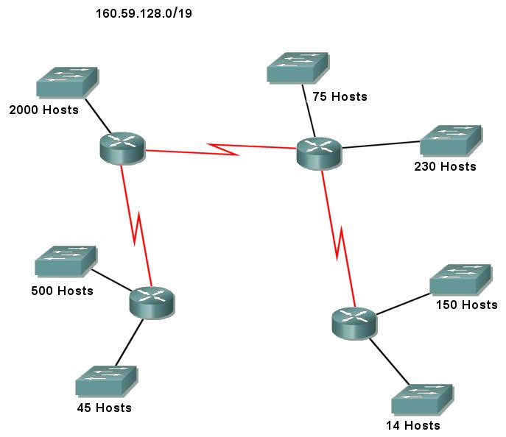
160.59.128.0 / 21
160.59.136.0 / 23
160.59.138.0 / 24
160.59.139.0 / 24
160.59.140.0 / 25
160.59.140.128 / 26
160.59.140.192 / 28
160.59.140.208 / 30
160.59.140.212 / 30
160.59.140.216 / 30
Solution - VLSM Exercise # 10

160.59.128.0 / 19
 | Network: | 1 | 0 | 1 | 0 | 0 | 0 | 0 | 0 | . | 0 | 0 | 1 | 1 | 1 | 0 | 1 | 1 | . | 1 | 0 | 0 | 0 | 0 | 0 | 0 | 0 | . | 0 | 0 | 0 | 0 | 0 | 0 | 0 | 0
 | Subnet Mask: | 1 | 1 | 1 | 1 | 1 | 1 | 1 | 1 | . | 1 | 1 | 1 | 1 | 1 | 1 | 1 | 1 | . | 1 | 1 | 1 | 0 | 0 | 0 | 0 | 0 | . | 0 | 0 | 0 | 0 | 0 | 0 | 0 | 0
 |  | Borrow 2 - 21 Network bits - 11 Host bits - Magic Number = 8
2000 Hosts | 160.59.128.0 / 21 | 1 | 0 | 1 | 0 | 0 | 0 | 0 | 0 | . | 0 | 0 | 1 | 1 | 1 | 0 | 1 | 1 | . | 1 | 0 | 0 | 0 | 0 | 0 | 0 | 0 | . | 0 | 0 | 0 | 0 | 0 | 0 | 0 | 0
 | 160.59.136.0 / 21 |  |  |  |  |  |  |  |  |  |  |  |  |  | • |  |  |  |  |  |  |  | 0 | 1 |  |  |  |  |  |  | •
 | 160.59.144.0 / 21 |  |  |  |  |  |  |  |  |  |  |  |  |  | • |  |  |  |  |  |  |  | 1 | 0 |  |  |  |  |  |  | •
 | 160.59.152.0 / 21 | 1 | 0 | 1 | 0 | 0 | 0 | 0 | 0 | . | 0 | 0 | 1 | 1 | 1 | 0 | 1 | 1 | . | 1 | 0 | 0 | 1 | 1 | 0 | 0 | 0 | . | 0 | 0 | 0 | 0 | 0 | 0 | 0 | 0
 | Subnet Mask: | 1 | 1 | 1 | 1 | 1 | 1 | 1 | 1 | . | 1 | 1 | 1 | 1 | 1 | 1 | 1 | 1 | . | 1 | 1 | 1 | 1 | 1 | 0 | 0 | 0 | . | 0 | 0 | 0 | 0 | 0 | 0 | 0 | 0
 |  | Borrow 2 More - 23 Network bits - 9 Host bits - Magic Number = 2
500 Hosts | 160.59.136.0 / 23 | 1 | 0 | 1 | 0 | 0 | 0 | 0 | 0 | . | 0 | 0 | 1 | 1 | 1 | 0 | 1 | 1 | . | 1 | 0 | 0 | 0 | 1 | 0 | 0 | 0 | . | 0 | 0 | 0 | 0 | 0 | 0 | 0 | 0
 | 160.59.138.0 / 21 |  |  |  |  |  |  |  |  |  |  |  |  |  | • |  |  |  |  |  |  |  |  |  | 0 | 1 |  |  |  |  | •
 | 160.59.140.0 / 21 |  |  |  |  |  |  |  |  |  |  |  |  |  | • |  |  |  |  |  |  |  |  |  | 1 | 0 |  |  |  |  | •
 | 160.59.144.0 / 21 | 1 | 0 | 1 | 0 | 0 | 0 | 0 | 0 | . | 0 | 0 | 1 | 1 | 1 | 0 | 1 | 1 | . | 1 | 0 | 0 | 0 | 1 | 1 | 1 | 0 | . | 0 | 0 | 0 | 0 | 0 | 0 | 0 | 0
 | Subnet Mask: | 1 | 1 | 1 | 1 | 1 | 1 | 1 | 1 | . | 1 | 1 | 1 | 1 | 1 | 1 | 1 | 1 | . | 1 | 1 | 1 | 1 | 1 | 1 | 1 | 0 | . | 0 | 0 | 0 | 0 | 0 | 0 | 0 | 0
 |  | Borrow 1 More - 24 Network bits - 8 Host bits - Magic Number = 256
230 Hosts | 160.59.138.0 / 24 | 1 | 0 | 1 | 0 | 0 | 0 | 0 | 0 | . | 0 | 0 | 1 | 1 | 1 | 0 | 1 | 1 | . | 1 | 0 | 0 | 0 | 1 | 0 | 1 | 0 | . | 0 | 0 | 0 | 0 | 0 | 0 | 0 | 0
150 Hosts | 160.59.139.0 / 24 |  |  |  |  |  |  |  |  |  |  |  |  |  |  |  |  |  |  |  |  |  |  |  |  |  | 1
 | Subnet Mask: | 1 | 1 | 1 | 1 | 1 | 1 | 1 | 1 | . | 1 | 1 | 1 | 1 | 1 | 1 | 1 | 1 | . | 1 | 1 | 1 | 1 | 1 | 1 | 1 | 1 | . | 0 | 0 | 0 | 0 | 0 | 0 | 0 | 0
 |  | Borrow 1 More - 25 Network bits - 7 Host bits - Magic Number = 128
75 Hosts | 160.59.140.0 / 25 | 1 | 0 | 1 | 0 | 0 | 0 | 0 | 0 | . | 0 | 0 | 1 | 1 | 1 | 0 | 1 | 1 | . | 1 | 0 | 0 | 0 | 1 | 1 | 0 | 0 | . | 0 | 0 | 0 | 0 | 0 | 0 | 0 | 0
 | 160.59.140.128 / 25 |  |  |  |  |  |  |  |  |  |  |  |  |  |  |  |  |  |  |  |  |  |  |  |  |  |  |  | 1
 | Subnet Mask: | 1 | 1 | 1 | 1 | 1 | 1 | 1 | 1 | . | 1 | 1 | 1 | 1 | 1 | 1 | 1 | 1 | . | 1 | 1 | 1 | 1 | 1 | 1 | 1 | 1 | . | 1 | 0 | 0 | 0 | 0 | 0 | 0 | 0
Next Page
Solution - VLSM Exercise # 10

 |  | Borrow 1 More - 26 Network bits - 6 Host bits - Magic Number = 64
45 Hosts | 160.59.140.128 / 26 | 1 | 0 | 1 | 0 | 0 | 0 | 0 | 0 | . | 0 | 0 | 1 | 1 | 1 | 0 | 1 | 1 | . | 1 | 0 | 0 | 0 | 0 | 0 | 0 | 0 | . | 1 | 0 | 0 | 0 | 0 | 0 | 0 | 0
 | 160.59.140.192 / 26 |  |  |  |  |  |  |  |  |  |  |  |  |  |  |  |  |  |  |  |  |  |  |  |  |  |  |  |  | 1
 | Subnet Mask: | 1 | 1 | 1 | 1 | 1 | 1 | 1 | 1 | . | 1 | 1 | 1 | 1 | 1 | 1 | 1 | 1 | . | 1 | 1 | 1 | 1 | 1 | 1 | 1 | 1 | . | 1 | 1 | 0 | 0 | 0 | 0 | 0 | 0
 |  | Borrow 2 More - 28 Network bits - 4 Host bits - Magic Number = 16
14 Hosts | 160.59.140.192 / 28 | 1 | 0 | 1 | 0 | 0 | 0 | 0 | 0 | . | 0 | 0 | 1 | 1 | 1 | 0 | 1 | 1 | . | 1 | 0 | 0 | 0 | 0 | 0 | 0 | 0 | . | 1 | 1 | 0 | 0 | 0 | 0 | 0 | 0
 | 160.59.140.208 / 28 |  |  |  |  |  |  |  |  |  |  |  |  |  | • |  |  |  |  |  |  |  |  |  |  |  |  |  |  |  | 0 | 1
 | 160.59.140.224 / 28 |  |  |  |  |  |  |  |  |  |  |  |  |  | • |  |  |  |  |  |  |  |  |  |  |  |  |  |  |  | 1 | 0
 | 160.59.140.240 / 28 | 1 | 0 | 1 | 0 | 0 | 0 | 0 | 0 | . | 0 | 0 | 1 | 1 | 1 | 0 | 1 | 1 | . | 1 | 0 | 0 | 0 | 0 | 0 | 0 | 0 | . | 1 | 1 | 1 | 1 | 0 | 0 | 0 | 0
 | Subnet Mask: | 1 | 1 | 1 | 1 | 1 | 1 | 1 | 1 | . | 1 | 1 | 1 | 1 | 1 | 1 | 1 | 1 | . | 1 | 1 | 1 | 1 | 1 | 1 | 1 | 1 | . | 1 | 1 | 1 | 1 | 0 | 0 | 0 | 0
 |  | Borrow 2 More - 30 Network bits - 2 Host bits - Magic Number = 4
2 Hosts | 160.59.140.208 / 30 | 1 | 0 | 1 | 0 | 0 | 0 | 0 | 0 | . | 0 | 0 | 1 | 1 | 1 | 0 | 1 | 1 | . | 1 | 0 | 0 | 0 | 0 | 0 | 0 | 0 | . | 1 | 1 | 0 | 1 | 0 | 0 | 0 | 0
2 Hosts | 160.59.140.212 / 30 |  |  |  |  |  |  |  |  |  |  |  |  |  | • |  |  |  |  |  |  |  |  |  |  |  |  |  |  |  |  |  | 0 | 1
2 Hosts | 160.59.140.216 / 30 |  |  |  |  |  |  |  |  |  |  |  |  |  | • |  |  |  |  |  |  |  |  |  |  |  |  |  |  |  |  |  | 1 | 0
 | 160.59.140.220 / 30 | 1 | 0 | 1 | 0 | 0 | 0 | 0 | 0 | . | 0 | 0 | 1 | 1 | 1 | 0 | 1 | 1 | . | 1 | 0 | 0 | 0 | 0 | 0 | 0 | 0 | . | 1 | 1 | 0 | 1 | 1 | 1 | 0 | 0
 | Subnet Mask: | 1 | 1 | 1 | 1 | 1 | 1 | 1 | 1 | . | 1 | 1 | 1 | 1 | 1 | 1 | 1 | 1 | . | 1 | 1 | 1 | 1 | 1 | 1 | 1 | 1 | . | 1 | 1 | 1 | 1 | 1 | 1 | 0 | 0

VLSM Exercise # 11
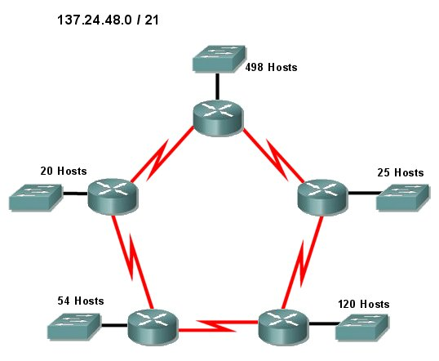
137.24.48.0 / 23
137.24.51.16 / 30
137.24.51.0 / 30
137.24.50.224 / 27
137.24.51.12 / 30
137.24.50.192 / 27
137.24.51.4/ 30
137.24.50.0 / 25
137.24.51.8 / 30
137.24.50.128 / 26

Solution - VLSM Exercise # 11

137.24.48.0 / 21
 | Network: | 1 | 0 | 0 | 0 | 1 | 0 | 0 | 1 | . | 0 | 0 | 0 | 1 | 1 | 0 | 0 | 0 | . | 0 | 0 | 1 | 1 | 0 | 0 | 0 | 0 | . | 0 | 0 | 0 | 0 | 0 | 0 | 0 | 0
 | Subnet Mask: | 1 | 1 | 1 | 1 | 1 | 1 | 1 | 1 | . | 1 | 1 | 1 | 1 | 1 | 1 | 1 | 1 | . | 1 | 1 | 1 | 1 | 1 | 0 | 0 | 0 | . | 0 | 0 | 0 | 0 | 0 | 0 | 0 | 0
 |  | Borrow 2 - 23 Network bits - 9 Host bits - Magic Number = 2
498 Hosts | 137.24.48.0 / 23 | 1 | 0 | 0 | 0 | 1 | 0 | 0 | 1 | . | 0 | 0 | 0 | 1 | 1 | 0 | 0 | 0 | . | 0 | 0 | 1 | 1 | 0 | 0 | 0 | 0 | . | 0 | 0 | 0 | 0 | 0 | 0 | 0 | 0
 | 137.24.50.0 / 23 |  |  |  |  |  |  |  |  |  |  |  |  |  | • |  |  |  |  |  |  |  |  |  | 0 | 1 |  |  |  |  | •
 | 137.24.52.0 / 23 |  |  |  |  |  |  |  |  |  |  |  |  |  | • |  |  |  |  |  |  |  |  |  | 1 | 0 |  |  |  |  | •
 | 137.24.54.0 / 23 | 1 | 0 | 0 | 0 | 1 | 0 | 0 | 1 | . | 0 | 0 | 0 | 1 | 1 | 0 | 0 | 0 | . | 0 | 0 | 1 | 1 | 0 | 1 | 1 | 0 | . | 0 | 0 | 0 | 0 | 0 | 0 | 0 | 0
 | Subnet Mask: | 1 | 1 | 1 | 1 | 1 | 1 | 1 | 1 | . | 1 | 1 | 1 | 1 | 1 | 1 | 1 | 1 | . | 1 | 1 | 1 | 1 | 1 | 1 | 1 | 0 | . | 0 | 0 | 0 | 0 | 0 | 0 | 0 | 0
 |  | Borrow 2 More - 25 Network bits - 7 Host bits - Magic Number = 128
120 Hosts | 137.24.50.0 / 25 | 1 | 0 | 0 | 0 | 1 | 0 | 0 | 1 | . | 0 | 0 | 0 | 1 | 1 | 0 | 0 | 0 | . | 0 | 0 | 1 | 1 | 0 | 0 | 1 | 0 | . | 0 | 0 | 0 | 0 | 0 | 0 | 0 | 0
 | 137.24.50.128 / 25 |  |  |  |  |  |  |  |  |  |  |  |  |  | • |  |  |  |  |  |  |  |  |  |  |  | 0 |  | 1 |  | •
 | 137.24.51.0 / 25 |  |  |  |  |  |  |  |  |  |  |  |  |  | • |  |  |  |  |  |  |  |  |  |  |  | 1 |  | 0 |  | •
 | 137.24.51.128 / 25 | 1 | 0 | 0 | 0 | 1 | 0 | 0 | 1 | . | 0 | 0 | 0 | 1 | 1 | 0 | 0 | 0 | . | 0 | 0 | 1 | 1 | 0 | 0 | 1 | 1 | . | 1 | 0 | 0 | 0 | 0 | 0 | 0 | 0
 | Subnet Mask: | 1 | 1 | 1 | 1 | 1 | 1 | 1 | 1 | . | 1 | 1 | 1 | 1 | 1 | 1 | 1 | 1 | . | 1 | 1 | 1 | 1 | 1 | 1 | 1 | 1 | . | 1 | 0 | 0 | 0 | 0 | 0 | 0 | 0
 |  | Borrow 1 More - 26 Network bits - 6 Host bits - Magic Number = 64
54 Hosts | 137.24.50.128 / 26 | 1 | 0 | 0 | 0 | 1 | 0 | 0 | 1 | . | 0 | 0 | 0 | 1 | 1 | 0 | 0 | 0 | . | 0 | 0 | 1 | 1 | 0 | 0 | 1 | 0 | . | 1 | 0 | 0 | 0 | 0 | 0 | 0 | 0
 | 137.24.50.192 / 26 |  |  |  |  |  |  |  |  |  |  |  |  |  |  |  |  |  |  |  |  |  |  |  |  |  |  |  |  | 1
 | Subnet Mask: | 1 | 1 | 1 | 1 | 1 | 1 | 1 | 1 | . | 1 | 1 | 1 | 1 | 1 | 1 | 1 | 1 | . | 1 | 1 | 1 | 1 | 1 | 1 | 1 | 1 | . | 1 | 1 | 0 | 0 | 0 | 0 | 0 | 0
 |  | Borrow 1 More - 27 Network bits - 5 Host bits - Magic Number = 32
25 Hosts | 137.24.50.192 / 27 | 1 | 0 | 1 | 0 | 0 | 0 | 0 | 0 | . | 0 | 0 | 1 | 1 | 1 | 0 | 1 | 1 | . | 1 | 0 | 0 | 0 | 1 | 1 | 0 | 0 | . | 1 | 1 | 0 | 0 | 0 | 0 | 0 | 0
20 Hosts | 137.24.50.224 / 27 |  |  |  |  |  |  |  |  |  |  |  |  |  |  |  |  |  |  |  |  |  |  |  |  |  |  |  |  |  | 1
 | Subnet Mask: | 1 | 1 | 1 | 1 | 1 | 1 | 1 | 1 | . | 1 | 1 | 1 | 1 | 1 | 1 | 1 | 1 | . | 1 | 1 | 1 | 1 | 1 | 1 | 1 | 1 | . | 1 | 1 | 1 | 0 | 0 | 0 | 0 | 0
Next Page

 |  | Borrow 3 More - 30 Network bits - 2 Host bits - Magic Number = 4
2 Hosts | 137.24.51.0 / 30 | 1 | 0 | 0 | 0 | 1 | 0 | 0 | 1 | . | 0 | 0 | 0 | 1 | 1 | 0 | 0 | 0 | . | 0 | 0 | 1 | 1 | 0 | 0 | 1 | 1 | . | 0 | 0 | 0 | 0 | 0 | 0 | 0 | 0
2 Hosts | 137.24.51.4 / 30 |  |  |  |  |  |  |  |  |  |  |  |  |  | • |  |  |  |  |  |  |  |  |  |  |  |  |  |  |  |  | 0 | 0 | 1
2 Hosts | 137.24.51.8 / 30 |  |  |  |  |  |  |  |  |  |  |  |  |  | • |  |  |  |  |  |  |  |  |  |  |  |  |  |  |  |  | 0 | 1 | 0
2 Hosts | 137.24.51.12 / 30 |  |  |  |  |  |  |  |  |  |  |  |  |  | • |  |  |  |  |  |  |  |  |  |  |  |  |  |  |  |  | 0 | 1 | 1
2 Hosts | 137.24.51.16 / 30 |  |  |  |  |  |  |  |  |  |  |  |  |  | • |  |  |  |  |  |  |  |  |  |  |  |  |  |  |  |  | 1 | 0 | 0
 | • |  |  |  |  |  |  |  |  |  |  |  |  |  | • |  |  |  |  |  |  |  |  |  |  |  |  |  |  |  |  |  | •
 | • |  |  |  |  |  |  |  |  |  |  |  |  |  | • |  |  |  |  |  |  |  |  |  |  |  |  |  |  |  |  |  | •
 | 160.59.140.252 / 30 | 1 | 0 | 1 | 0 | 0 | 0 | 0 | 0 | . | 0 | 0 | 1 | 1 | 1 | 0 | 1 | 1 | . | 1 | 0 | 0 | 0 | 1 | 1 | 0 | 0 | . | 1 | 1 | 1 | 1 | 1 | 1 | 0 | 0
 | Subnet Mask: | 1 | 1 | 1 | 1 | 1 | 1 | 1 | 1 | . | 1 | 1 | 1 | 1 | 1 | 1 | 1 | 1 | . | 1 | 1 | 1 | 1 | 1 | 1 | 1 | 1 | . | 1 | 1 | 1 | 1 | 1 | 1 | 0 | 0

